Evolution in Action: Antibiotic Resistance
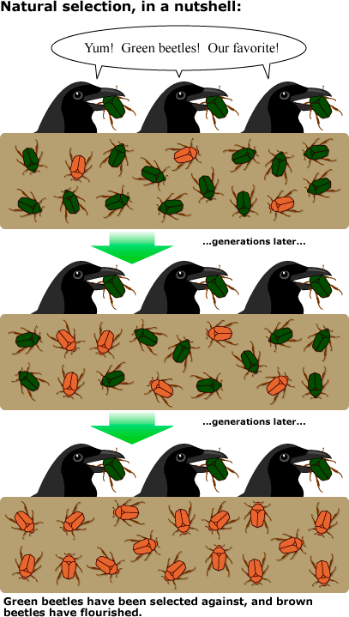
Evolution and Natural Selection
Evolution is one of the driving factors in biology. It
is simply the concept that organisms, and therefore
populations, change over time. Evolution can result
in the appearance of entirely new species, or even
the extinction of an entire species. Evolution is a
consequence of the interaction of four factors:

- The potential for a species to increase
in number

- The genetic variation of individuals in a species
due to mutation and sexual reproduction

- Competition for an environment’s limited supply
of the resources that individuals need in order to
survive and reproduce

- The ensuing proliferation of those organisms
that are better able to survive and reproduce
in that environment

Natural selection is a key component of evolution.
Natural selection is the process by which an
organism’s traits increase or decrease within a
population depending on the pressure placed on
the population by the environment. What does that
mean? Basically, it is simply a question of which
organisms will be better suited to survive in an
environment. It is easy to observe that there is a
variation in traits among populations. For example,
human traits have a wide variety of variation
including different hair color, eye color, or
University of California Museum of Paleontology's Understanding Evolution (http://evolution.berkeley.edu)

even blood types.

Natural selection occurs only if there is both (1) variation in the genetic information between organisms in a population and (2) variation in the expression of that genetic information—that is, trait variation—that leads to differences in performance among individuals (NGSS LS4B). For example, imagine a fake population of humans that live isolated on a remote island. The human population on the island only has Type O blood, and the individuals have been infected with a virus that only infects Type O blood cells. The virus is lethal. What would happen to the population? With no genetic variation in blood types, the population would likely go extinct. If there happened to be a few individuals with Type A or Type B blood types, they could survive and be able to reproduce, preserving the species.

Microbes and Antibiotics

Bacteria, fungi, protists, algae, and viruses are all considered microorganisms, or microbes. Most microbes are not visible with the human eye unless they collect together in large groups, or colonies. Most people associate microbes, such as bacteria and viruses, with illness and do not realize that they are essential to life on Earth. Microbes have multiple beneficial functions including:
- recycling nutrients from detritus, or dead material, into smaller components to be used by living organisms.
- acting as natural flora that live on and in our bodies symbiotically. There are more than 10x the microbes on or in our bodies than there are human cells in the body. These microbes protect us from harmful bacteria and assist in digestion.
- efficiently performing fermentation and provide foods such as bread, wine, and cheese.
- breaking down household and industrial toxic wastes and pollution.
- purifying contaminated water.
- producing important products such as vitamins, xanthan gum, and antibiotics.

As you can see, microbes have many beneficial and important functions. Unfortunately, antibiotics meant to destroy pathogenic microbes that cause illness often kill off beneficial microbes as well. Most of us assume we are only exposed to antibiotics if we are prescribed them as medications to treat infection. In reality, we are exposed to antibiotics daily. More than a million pounds of antibiotic are added to the environment per week.

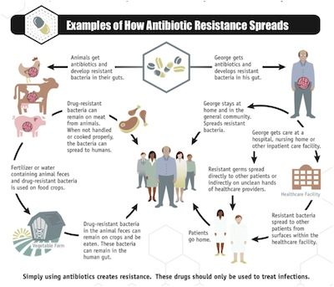
Antibiotics can be found in:

- Pharmaceutical prescriptions

- Sewage and treated wastewater

- Medical waste

- Discharged water from pharmaceutical plants

- Household “antibacterial” products such as toothpaste, plastics, paints, and bleach

- Fruits, vegetables, and crops that have been sprayed with antibiotics

- Animal products such as beef, chicken, fish, and pork that have been fed antibiotics

http://legacy-cdn-assets.answersingenesis.org/assets/images/articles/2013/09/cdc-chart1.jpg

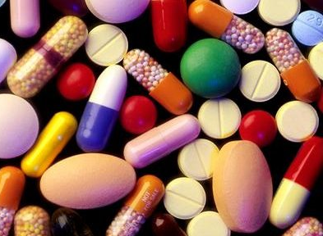
How Do Antibiotics Work?
Antibiotics are medicines capable of killing or preventing
the reproduction of microbes, specifically bacteria. An
antibiotic is a substance that is toxic to specific bacteria.
Antibiotics can affect bacteria in a variety of ways. For
example, they may damage one of the proteins that
convert glucose to energy, break down proteins that
make up the cell wall or membrane, or they may prevent
proteins needed for reproduction from being formed, as
well as many other ways.
http://news.bbcimg.co.uk/media/images/56785000/jpg/_56785761_000163150-1.jpg

The Evolution of Microbes: Antibiotic Resistance
The overexposure of microbes to antibiotics has provided environmental conditions in which the microbes must change, or evolve, to survive the use of specific antibiotics. How does a microbe evolve? Evolution is driven by environmental pressure. An organism that is under pressure to survive must change or risk becoming extinct. Mutation is the mechanism of evolution. Microbes with mutations that are resistant, or immune, to an antibiotic will survive to reproduce, and they will pass the mutation to their offspring.

As an example, Methicillin-resistant Staphylococcus aureus (MRSA) is one of the most common and dangerous antibiotic-resistant organisms. Staphylococcus aureus is a common bacterium found on human skin. When the skin is broken open, it can cause a

Staph infection. Methicillin is an antibiotic that blocks the protein responsible for creating a substance that forms the cell wall surrounding S. aureus. When exposed to methicillin, normal S. aureus is unable to form its cell wall, which causes cell death. MRSA has a mutation of the protein, and the methicillin can no longer block it because its shape has changed. This effectively prevents methicillin from fighting against MRSA.

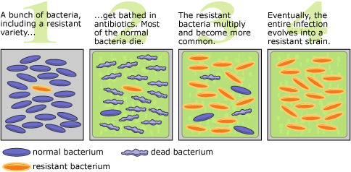

http://evolution.berkeley.edu/evolibrary/images/interviews/resistance.gif

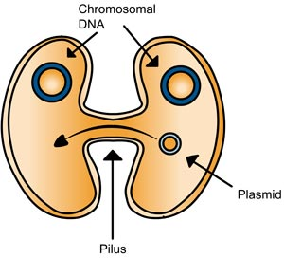
Microbes also have the ability to transfer portions of their DNA
between each other, which allows them to pass their mutation to
other microbes, even from different species. This ability, combined
with the ability of microbes to reproduce quickly, allows a gene
mutation to be passed quickly among microbe populations.
Overexposure to a specific antibiotic, such as penicillin, allows
microbes that have a mutation that allows them to be resistant to
penicillin, to survive and reproduce. As a result, eventually
penicillin will become completely ineffective. According to the
Center for Disease Control (CDC), more than 70% of infections
contracted during hospitalization are resistant to at least one antibiotic.
http://www.wiley.com/

We can relate each of the natural selection factors to the evolution of antibiotic resistance:
- Potential for increase in number. When a microbe with a resistant gene is exposed to a specific antibiotic, it still has the potential to increase the number of its species.
- Heritable genetic variation. The mutation that created the resistant gene is different from the bacteria population with the normal gene. Organisms with the resistant gene will pass the gene onto their offspring.
- Competition for limited resources. The bacteria population that is resistant will win out in competition for limited resources over the population that is not resistant when
exposed to an environment with the antibiotic present.
- Proliferation of organisms better able to survive. The bacteria that have the resistant gene will be better able to survive and reproduce when exposed to the antibiotic to which it is resistant (not affected).

Review Questions – answer questions on a separate sheet of paper
- What is evolution?
- What four factors must interact for evolution to occur? For each factor, give an example.
- What is natural selection?
- Why is it important that a population have genetic variation for natural selection, and therefore evolution, to occur?
- What are microbes? Give three examples.
- What are three beneficial functions of microbes?
- Looking at where antibiotics are found in the environment, how have you personally been exposed to antibiotics? What does this mean for the "natural flora" that live in and on your body?
- How are antibiotics able to stop microbes?
- Why would a microbe develop resistance to an antibiotic?
- Explain how MRSA developed and why it is no longer affected by methicillin.
- Why does the ability of microbes to transfer DNA between each other increase the rate at which they can evolve?
- What percentage of hospital infections are caused by antibiotic-resistant microbes?
- Using the four factors for evolution, describe how antibiotic resistance meets each factor.
- Argue for why we would not want to get rid of all bacteria.
- Should you take antibiotics for viral infections like the common cold? Why or why not?
- Hypothesize why antibiotics are used on crops and farm animals.
- What is the problem with increased use of antibacterial household products?

Antibiotic Resistance
You are part of a medical lab team that works for HASPI Hope Hospital. Penicillin is an antibiotic commonly used at your hospital to treat skin infections. Recently, the staff has noticed a decline in the effectiveness of penicillin on Staphylococcus aureus infections.
S. aureus bacteria are the cause of Staph infections. Two patients have just come to the hospital and both are exhibiting symptoms of a Staph infection. Since antibiotic-resistant Staph infections can get worse quickly, your team has been asked to test the bacteria from both patients for resistance to penicillin. If either patient is resistant, it will be important to change to a different antibiotic as soon as possible. NOTE: Real bacteria are being used in this lab investigation, so it is important to take precautions when handling the cultures and plates.

Materials

Petri plates
Luria broth agar
Cotton swabs
Patient A culture
Patient B culture
Gloves
Penicillin disks (2)
Forceps
Permanent Marker

observations, or required response to each task on the right.
Part A: Set Up
Task |  | Response
1 | Your instructor has already poured agar into a petri plate. Collect a plate. DO NOT OPEN THE PLATE UNTIL DIRECTED TO DO SO!
2 | Using the permanent marker, separate and label the bottom of your plate into three areas: Control, Patient A, and Patient B. Put your initials on the edge of the plate as well. See Figure A for an example. | Figure A  Patient A  Patient B  Control
3 | The Control area of your plate will have no antibiotic and no bacteria, the Patient A area will have bacteria collected from Patient A and a penicillin disk, and the Patient B area will have bacteria collected from Patient B and a penicillin disk.
4 | Whoever will be transferring the patient cultures to your plate will need to be wearing the pair of gloves.
5 | Take your plate and a cotton swab to the bacteria culture for Patient A. Your teacher has placed it at a central location in the room.
6 | When removing the lid from the patient bacteria cultures or your own petri plate, it is very important to not remove the lid completely! Contaminants in the air can easily settle in the bottle or dish if the lid is completely removed. Instead, hover the lid over the bottle or plate. | a. What will each area of your plate actually contain?

7 | Open the Patient A bottle slightly. DO NOT lift the lid any further than needed to insert the swab. Only a small amount of bacteria is needed. |  | b. What is in the patient culture broth?
8 | Dip the cotton swab into the broth. The broth is used to grow large amounts of the bacteria culture collected from the patient.
9 | Carefully remove the cotton swab and close the lid on the patient culture. |  | 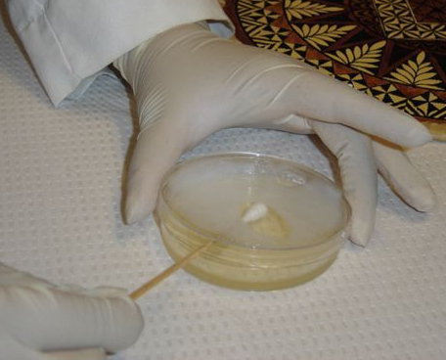
10 | Lift the lid of your petri plate slightly to allow you to place the cotton swab inside.
11 | Very gently drag the cotton over the Patient A area of the plate. Cover the entire area. DO NOT press on the swab or break the agar.
12 | Remove the cotton swab and lower the petri plate lid closed. Discard your cotton swab according to your teacher’s instructions.
13 | Repeat steps 4 – 12 for Patient B, dragging the cotton swab over the Patient B area of the plate.
14 | Obtain 2 penicillin disks (this you may change) from your teacher. Lift the lid of your petri plate slightly and using forceps, place a penicillin (or another antibiotic) disk in the center of the Patient A area and a penicillin disk in the center of the Patient B area. | c. Hypothesize what will occur in each area of the plate.  d. What is the purpose of the control area of the plate? Why is this important?  e. What is the purpose of incubation?
15 | The penicillin disks each have 10 μL of penicillin. If the bacteria are killed by the penicillin, no bacteria will grow in the area surrounding the penicillin disk.
16 | The control area of the plate will be left empty.
17 | Hand your plate in to your teacher for incubation. Incubation allows time for the bacteria to grow in an ideal environment. If an incubator is available, the plate will be ready the next day. If not, it will be 2-3 days before the plate will be ready to observe.
18 | Remove and discard the gloves.

Part B: Observing The Plate
Task |  | Response
1 | Collect your plate. Do not remove the lid. | Figure B  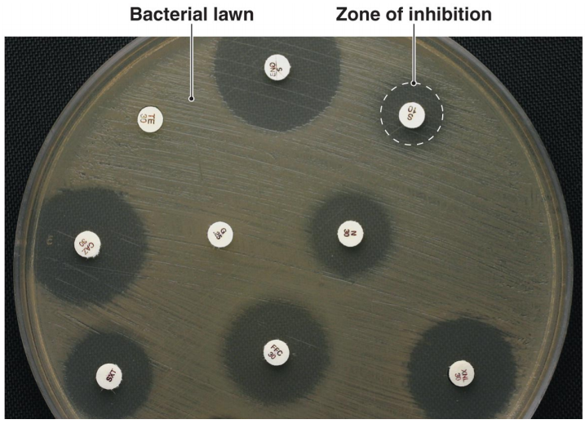  http://classconnection.s3.amazonaws.com/937/flashcards/696937/png/diffusion_susceptibility_test1318384479693.png
2 | See Figure B for an example of bacterial lawn growth and the zone of inhibition surrounding the antibiotic disk. A zone of inhibition indicates that the antibiotic was effective in killing and/or preventing the bacteria from reproducing.
3 | Observe the bacterial growth on your plate. Draw what you observe on Diagram A, and record your observations in Table 1.
4 | Give the plate to your teacher for disposal.
5 | Complete the Analysis Questions based on your results.
Diagram A

Table 1. Antibiotic
Patient A
Patient B
Resistance Test Results
Plate  Area | Results Description  Describe your results. Is there evidence of antibiotic resistance?
Patient A
Patient B
Control | Control

Analysis & Interpretation
Analysis Questions – answer questions on a separate sheet of paper
- How were you able to determine whether the penicillin was effective or not in destroying the bacteria?
- What is the zone of inhibition?
- Do either of your patients exhibit a Staph infection that is antibiotic resistant? Explain your answer using the lab results.
- What treatment would you recommend for each patient? Why?
- Why was the control area of the plate important? What might you assume if any bacteria growth had appeared in the control area?
- Why was penicillin used to treat the patients with Staph infections?
- Research and describe the symptoms of a Staph infection.
- What might happen to a patient if the antibiotic used to treat a Staph infection was ineffective?

